**Substance Usage and Personal Correlating Effects**

Eastern Connecticut State University, MAT 315

Andrew Cutter, Sean Mitchell, and Zachary Zaremba-Flores

May 9th, 2023

**Abstract**

This study aims to explore the impact of skipping class, religious importance, and hours worked per week on whether or not a student attends a four-year college or university post-graduation, marijuana use, and average grade among 12th-grade students. To analyze these relationships, we employ chi-squared tests, graphs, and time series. By examining the associations between these variables, we can better understand the key factors influencing a student's decision to pursue higher education, their average grade, and marijuana use. Although other variables may also affect these outcomes, our selected variables are considered major influencers. With this information, we may be able to predict a student's average grade, their likelihood of continuing their education, and their frequency of marijuana use. Our findings indicate a significant association between skipping class and marijuana use, as well as between religious importance and high school grades, shedding light on the potential consequences of these factors on students' lives.

**Table of Contents**

Introduction.....................................................................................................................................4

Methodology...................................................................................................................................4

Discussion.......................................................................................................................................5

Average Grade & Religious Importance.............................................5

College Intentions & Affecting Factors...............................................8

Skipping School & Drug Usage........................................................16

Conclusion....................................................................................................................................21

Appendix.......................................................................................................................................22

References.....................................................................................................................................25

**Introduction**

The final years of high school are a critical period in a student's life, during which personal beliefs, substance use, and academic achievement can significantly impact their future. In this study, we aim to explore the associations between religious importance, high school grade, and marijuana use among 12th-grade students. By understanding these relationships, we hope to shed light on the complex interplay between personal beliefs, substance use, and academic performance, providing valuable insights for educators, policymakers, and parents.

Through the use of graphs, tables, chi-squared tests, and literature findings, we will analyze the connections between average high school grade, religious importance, and marijuana use. We will examine the relationship between the frequency of skipping school and marijuana use, as well as the link between religious importance and academic performance.

By understanding these relationships, we can identify potential areas for intervention and support, helping students navigate the challenges of their final years in high school and fostering an environment that promotes academic success and personal well-being.

**Methodology**

Surveys for Monitoring the Future (MTF) are conducted annually and use large samples that represent the nation. This study began in 1975 and around 1400 variables are found each year. The study is designed to explore changes in many important values, behaviors, and lifestyle orientations of the American youth. There are two different goals when it comes to this study. The first is to provide an accurate description of the youth population of interest each year, and to quantify the direction and rate of the changes taking place among them over time. The second goal is to explain the relationships and trends observed.

The variables chosen for study from Monitoring the Future were: marijuana usage, college attendance, and average grades. Among them, 6 were chosen to represent a quantified correlation between personal issue, and substance usage. The variables’ correlation was recognized by using statistical bivariable techniques such as constructing a two-way table and performing a chi-squared test on each response variable and its explanatory variables.

We are going to use chi-square tests to look for relationships between skipping class, hours worked per week, religion, the rates of students who are planning on going to college, what grades they have, how often they use marijuana, etcetera. We will use frequency tables, graphs, and time series to visualize the data for each. Among this data, the variables chosen will have provided researched information for background. Ultimately, through these methods, a conclusion will be drawn on the academic response variables and their correlation to personal aspects, and substance usage.

**Discussion**

**Average Grades by Religious Importance**

When looking at many variables that may affect outcome variables, it is important and interesting to see how other studies in the past relate and if they have similar outcomes. We found one study that is very similar to our question of how religious importance can impact average grade. In this study, the effects of religious attendance, religious importance, and gender on well-being, substance use, and academic engagement were examined among early adolescents from rural schools. While the sample size was only 683 and it was only for rural schools, we still thought the conclusions and data would be interesting. It was found that “Adolescents who reported that religion was important in their lives reported lower school misbehavior and higher motivation, although those with high religious attendance had higher grades.” (Milot & Ludden, 2009). This agrees with our prediction that there is a significance between religious importance and average grade.

***Findings on Average Grade and Religious Importance***

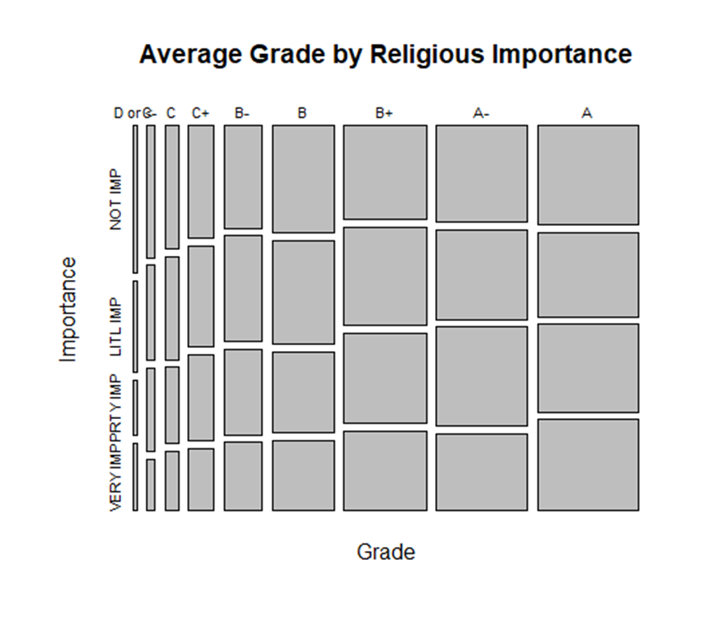

Figure 1: Correlation between average high school grade and how important religion is among 12th grade students in 2019.

As seen in the figure above, religious importance for A and A- students is pretty evenly spread out. However, once it starts going to lower grades such as B’s and C’s, the percentage of students with these grades are higher for student who don’t view religion as important compared to the ones that do. For B students for example, the percentage who view religion as not important is 2.6 as well as little importance and for pretty important the percentage us 2.2 and very important is 1.7 percent. This seems to be a trend as the grades go lower, the percentage of students who view religion as not important is lower than the percentage who view it as important.

|  |  |  |  |  |
| --- | --- | --- | --- | --- |
| Table of Average Grade and Religious Importance (Row Percentages) | | | | |
| Grade: | Not Important | Little Importance | Pretty Important | Very Important |
| D or < | .4 | .2 | .1 | .2 |
| C- | .7 | .5 | .4 | .3 |
| C | 1.1 | .9 | .7 | .5 |
| C+ | 1.9 | 1.7 | 1.5 | 1 |
| B- | 2.6 | 2.6 | 2.2 | 1.7 |
| B | 4.4 | 4.3 | 3.3 | 2.9 |
| B+ | 5.1 | 5.5 | 4.9 | 4.4 |
| A- | 5.8 | 5.5 | 6 | 4.7 |
| A | 6.7 | 5.7 | 5.9 | 6.2 |

Table 1: Row percentages of average grade and religious importance of 12th grade students in 2019.

|  |  |  |  |
| --- | --- | --- | --- |
| Chi-Squared Significance Test | | | |
| Religious Importance and Average Grade | X-squared = 91.921 | df = 24 | p-value < 6.916e-10 |

Table 2: Values of X-squared, Degrees of Freedom, and P-Value of the tested associations in the Chi Squared Significance Test.

After running a Chi Squared test for religious importance in association with the average high school grade, it came out with a p-value of less than 6.916e-10. Since this value is much less than the threshold of a .05 significance level, the null hypothesis can safely be considered false, meaning there is an association between average high school grade and religious importance.

**Collegiate Intention by Work Hours, Substance Usage, and School Skipped**

Another cause for academic influence is found in the usage of alcohol in or before collegiate education (El Ansari et al., 2013). El Ansari and colleagues reported that “20-25% of college students reported that they had a drinking problem,” (2013). The study found that in the case of those who participated in frequent ‘heavy drinking’, exhibited a negative impact on their grade point averages. The Ceneters of Disease Control and Prevention found, “13% of US high school students with mostly A’s reported current binge drinking, compared to 23% of students with mostly D/F’s,” (2021).

Students who are affected by substance abuse, like alcohol, are more likely to see negative effects on their academics (Centers for Disease Control and Prevention, 2021). According to the Drug Enforcement Administration, students who drop out of school are 2x as likely to be marijuana users than those who aren’t (2021).

***Findings of Intent to Attend College***

The variable of “Will Do 4-Year College” from the database Monitoring the Future was selected. Collegiate intention was chosen as an area of interest to show the effects of substance usage on a student, and whether it would deter a student from attending and graduating from a 4-year college. The substances used to measure this statistic were the ones mentioned, alcohol and marijuana. Other, personal, supplementary variables were used to measure their effects on college intentions as well. Initially, an understanding of base level college intent was required.

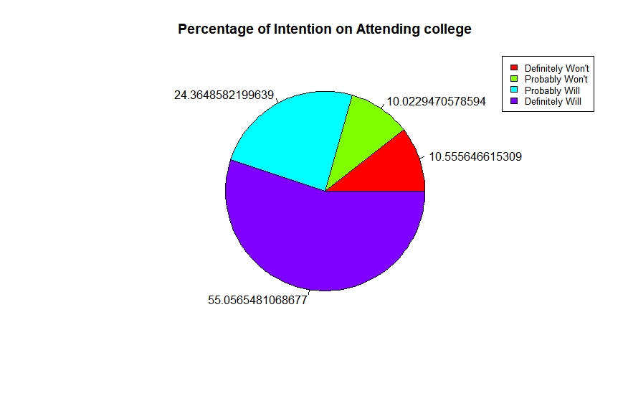

Figure 2: Intention on Attending College

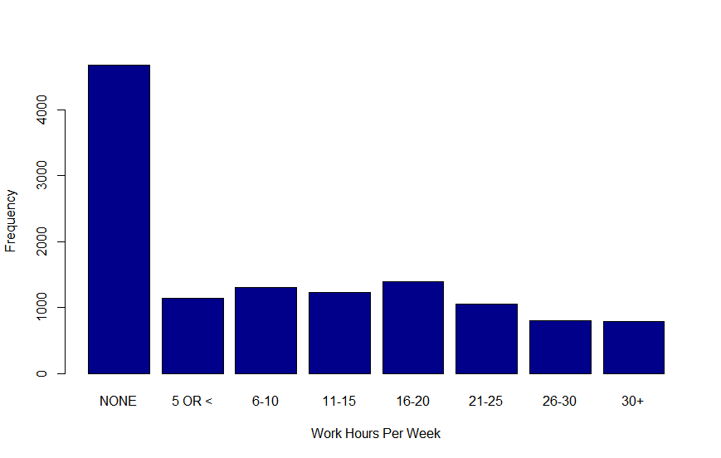

Figure 3: Frequency of work hours for high school seniors

Of the 1400 or so people who were polled from the dataset, about two-thirds of them showed some intent on attending (Figure 2). Also, an overwhelming majority of those high school seniors did not work at all (Figure 3), and a prediction was made that the number of hours worked would negatively correlate to college intentions

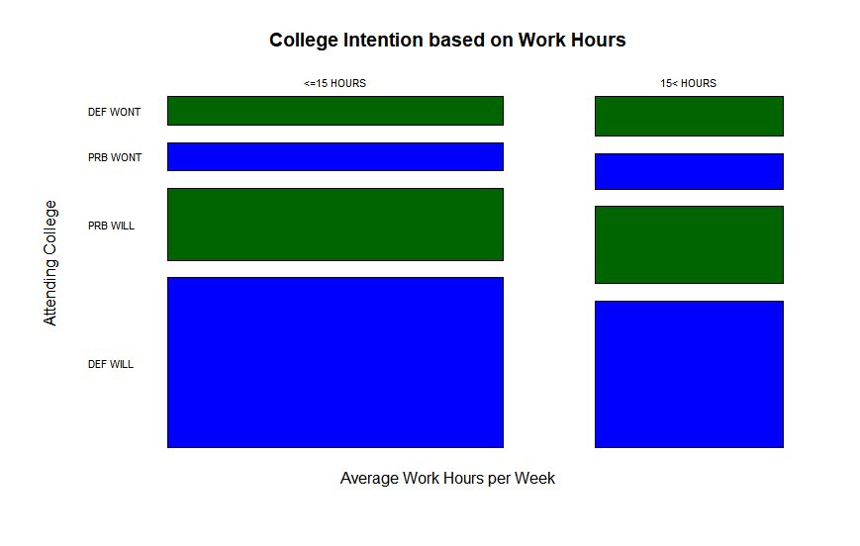

Figure 4: A chi-squared test found a chi-squared statistic of 77.503, 3 degrees of freedom with a significant p-value of 2.2 x 10-16

The statistic performed, denoted in figure 4, found that as work hours increased, the intention to attend college decreased resulting in a strong negative correlation. Most students from this study worked less than or equal to 15 hours (Figure 4), and that majority were more likely to have strong feelings about attending college than those who worked more than 15 hours. The same can be said of the inverse, and that people who were working more than 15 hours per week were more likely to say they weren’t likely to attend college.

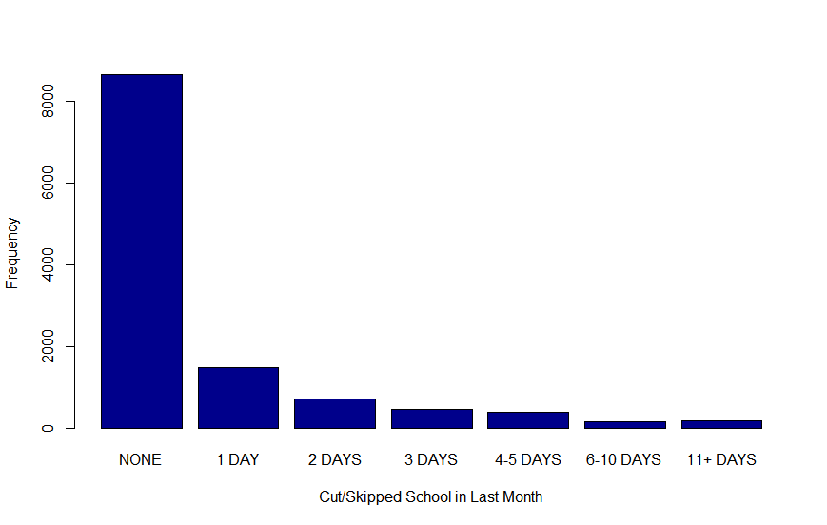

Figure 5: Frequency of skipped school days in last month

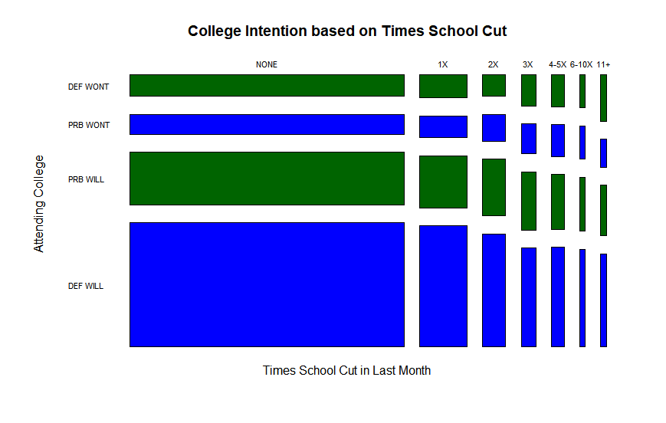

Figure 6: A chi-squared test found a chi-squared statistic of 98.43, 18 degrees of freedom with a significant p-value of 4.29 x 10-13

|  |  |  |  |  |
| --- | --- | --- | --- | --- |
| Table of College Intentions, and Occasions of Cutting School in last Month | | | | |
|  | Definitely Won’t | Probably Won’t | Probably Will | Definitely Will |
| None | 7.17% | 6.44% | 17.35% | 40.93% |
| 1X | 1.29% | 1.23% | 2.95% | 6.8% |
| 2X | 0.6% | 0.7% | 1.56% | 3.11% |
| 3X | 0.53% | 0.5% | 1% | 1.7% |
| 4-5X | 0.48% | 0.4% | 0.82% | 1.5% |
| 6-10X | 0.19% | 0.19% | 0.3% | 0.57% |
| 11+ | 0.32% | 0.19% | 0.34% | 0.63% |

Table 3: Row percentages of college intentions and occasions of cutting school.

A very high majority of students didn’t skip school in the last month (at the time of the survey) (Figure 5). The chi-squared test finds that the variables of college intention and skipping school are correlated. The results show that most of the students, even the ones that missed more than 3 days, were more likely than not to attend college (Table 3). This shows that the correlation between the variables has a positive increase, but cutting school doesn’t necessarily or logically mean that someone is more likely to attend college. Simply, cutting schools has little effect over whether they will attend.

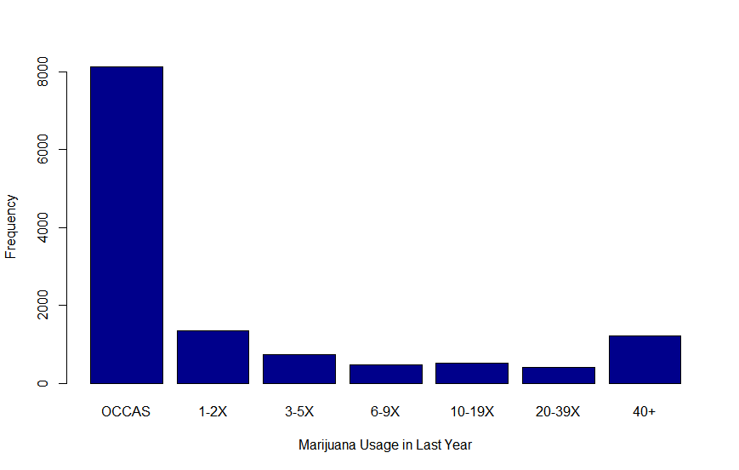

Figure 7: Marijuana Occasions

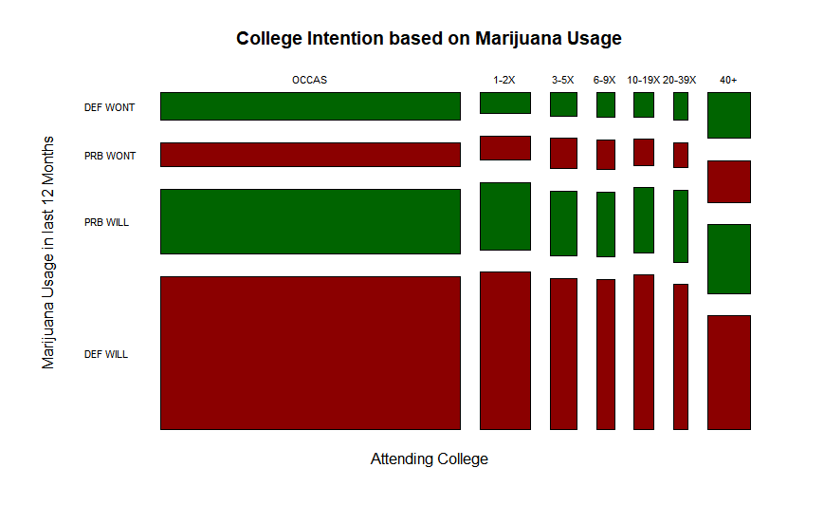

Figure 8: A chi-squared test found a chi-squared statistic of 140.78, 18 degrees of freedom with a significant p-value of 2.2 x 10-16

|  |  |  |
| --- | --- | --- |
| Table of College Intentions, by Marijuana Usage in Last 12 Months | | |
|  | Likely Will Attend | Likely Won’t Attend |
| At Most 5 Times | 64.8% | 15.07% |
| Between 5 and 20 Times | 6.38% | 1.5% |
| At Least 20 Times | 8.6% | 3.5% |

Table 4: Factored, row percentages on college intentions by marijuana usage.

Like cutting school, there is a vast majority of survey students who had very little marijuana in the last year. However, the correlation between marijuana usage and college intent is very high (Figure 7). There are a little over 1400 participants who used marijuana 20 times in the last 12 months, and of those individuals almost half of them would prefer not to go to college (Table 4). This significance is seen through the significant p-value, which is comparable to the overall significance of the work hours as well.

Along with the use of marijuana, alcohol usage was also tested. The chi-squared test performed resulted in a p-value of 0.000183. While that does ascertain significance, its p-value is very close to the null hypothesis, especially compared to marijuana. Someone who drank more than 40 times had a good chance of not going to college, they were for the most part still likely to go to college. The reasoning for this can be said to be alcohol's place in society, and how normalized it is.

Matched with the research from before, outside factors do have at least some effects on someone's intention to go to college. The status of people who were working high hours in college is likely that there is another reason why they must work so often. In the case of alcohol and marijuana, large amount of substance usage from both areas led to an increase in the number of people who were not interested in attending college.

**School Days Missed by Skipping and Marijuana Usage**

In examining the relationship between school days missed due to skipping or "cutting" and lifetime marijuana or hashish use among high school seniors, it is helpful to consider related studies. McCaffrey et al. (2010) investigated the association between marijuana use and high school dropout rates, finding a significant connection. Although not directly addressing the specific question, this study suggests that there might be a link between students who frequently skip school and those who engage in marijuana or hashish use. Further research is needed to confirm the relationship and better understand the underlying factors influencing this connection.

***Findings on School Days Missed Due to Skipping and Marijuana Use***

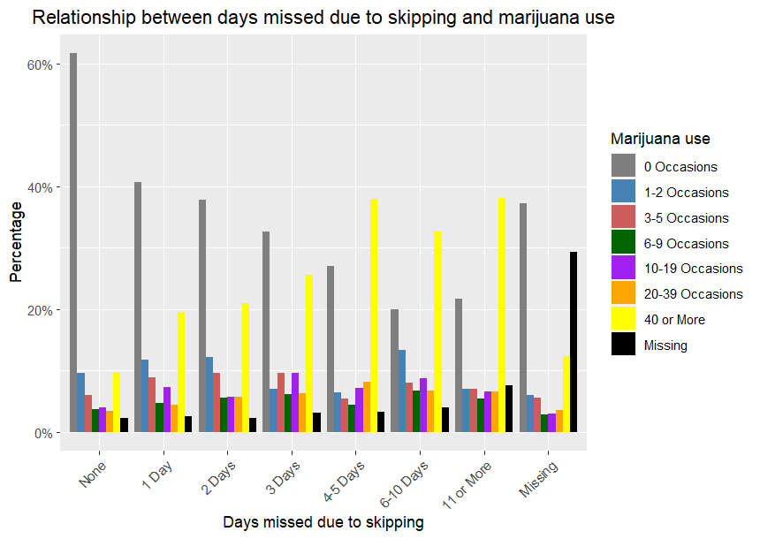

**Figure 9**: Correlation between school days missed due to skipping and lifetime marijuana use among 12th-grade students.

As seen in the figure, the percentage of students with higher occasions of marijuana use tends to increase with the number of school days missed due to skipping. This observation is further supported by the Chi-squared test results, which indicate a statistically significant association between these two variables.

**Table of Average Days Missed Due to Skipping and Marijuana Use (Row Percentages)**

|  |  |  |  |  |  |  |  |  |
| --- | --- | --- | --- | --- | --- | --- | --- | --- |
| **Days missed due to skipping** | **0 Occasions** | **1-2 Occasions** | **3-5 Occasions** | **6-9 Occasions** | **10-19 Occasions** | **20-39 Occasions** | **40 or More** | **Missing** |
| None | 61.64% | 9.54% | 5.95% | 3.76% | 3.95% | 3.36% | 9.54% | 2.25% |
| 1 Day | 40.72% | 11.79% | 8.91% | 4.69% | 7.37% | 4.42% | 19.56% | 2.55% |
| 2 Days | 37.72% | 12.21% | 9.60% | 5.62% | 5.76% | 5.76% | 20.99% | 2.33% |
| 3 Days | 32.60% | 7.00% | 9.63% | 6.13% | 9.63% | 6.35% | 25.60% | 3.06% |
| 4-5 Days | 27.05% | 6.45% | 5.46% | 4.47% | 7.20% | 8.19% | 37.97% | 3.23% |
| 6-10 Days | 20.00% | 13.33% | 8.00% | 6.67% | 8.67% | 6.67% | 32.67% | 4.00% |
| 11 or More | 21.74% | 7.07% | 7.07% | 5.43% | 6.52% | 6.52% | 38.04% | 7.61% |
| Missing | 37.20% | 6.07% | 5.52% | 2.91% | 3.03% | 3.58% | 12.38% | 29.31% |

**Table 5**: Row percentages of school days missed due to skipping and marijuana use among 12th-grade students.

From the table, we can observe that as the number of school days missed due to skipping increases, the percentages of students with higher occasions of marijuana use also tend to increase. For example, among students who missed 4-5 days of school, 37.97% reported 40 or more occasions of marijuana use, while this percentage is only 9.54% for those who did not miss any school days. This trend can be observed throughout the table, reinforcing the conclusion that there is a significant association between marijuana use and school days missed due to skipping.  
**Chi-Squared Significance Test**

|  |  |  |  |
| --- | --- | --- | --- |
|  | X-squared | Degrees of Freedom (df) | p-value |
| Marijuana Use and Skipping School Days | 3030 | 49 | < 2.2e-16 |

**Table 6**: Values of X-squared, Degrees of Freedom, and P-Value of the tested associations in the Chi-Squared Significance Test.

After running a Chi-Squared test for the relationship between school days missed due to skipping and marijuana use, we obtained a p-value of less than 2.2e-16. Since this value is much less than the threshold of a 0.05 significance level, we can reject the null hypothesis, meaning there is a significant association between the number of school days missed due to skipping and lifetime marijuana use among high school seniors in the United States.

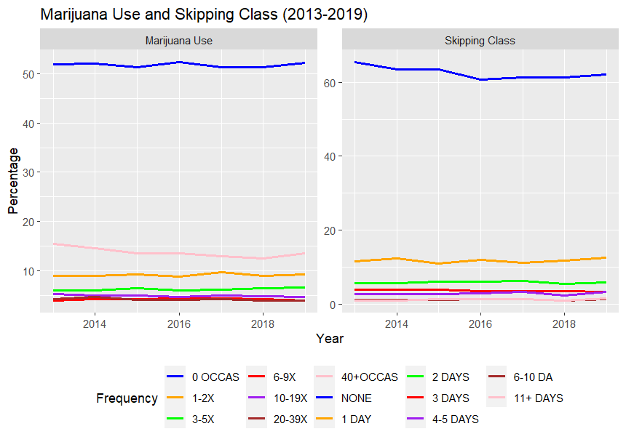

**Figure 10**: Time Series Plot of Correlation between school days missed due to skipping and lifetime marijuana use among 12th-grade students from the Years 2013 to 2019

As an additional and interesting aspect of the project, we created a time series plot of the given variables for each year from 2013 to 2019. The time series plots revealed fluctuations in both marijuana use, and days skipped during this period. Upon examining the provided graph illustrating the time series data for marijuana use and skipping school days from 2013 to 2019, it becomes evident that a relatively consistent pattern emerges over the years. Throughout this period, the graph indicates that the proportion of students with no instances of marijuana use has remained around 51-52%, peaking slightly in 2016 at 52.4%. The percentage of students with 40 or more occasions of marijuana use reaches its apex in 2013 at 15.4%, experiencing minor fluctuations over the years and settling at 13.6% in 2019.

As for skipping school, the graph displays a consistently high percentage of students who have not missed any school days due to skipping, with values ranging from 60.7% to 65.5%, the highest percentage being in 2013. The percentage of students who missed 11 or more school days due to skipping remains relatively low, staying at or below 1.5% throughout the period.

This graphical analysis highlights the persistence of the relationship between marijuana use and skipping school days, as both variables exhibit similar patterns of distribution across the years.

**Conclusion**

From the analysis of religious importance, high school grade, and marijuana use among 12th graders, as well as from the graphs, tables, chi-squared tests, and literature findings, it can be concluded that there are associations between average high school grade, religious importance, and marijuana use. The data indicate that students who miss more school days due to skipping are more likely to have higher occasions of marijuana use, and this relationship is statistically significant. Furthermore, students who place greater importance on religion tend to have higher average grades, suggesting a connection between religious importance and academic performance. These findings emphasize the complex interplay between personal beliefs, substance use, and academic achievement in high school seniors, shedding light on potential areas of intervention and support for students.

**Appendix A**

For religious importance, the survey question asked was “How important is religion in your life?”. For average high school grade, the question was “Which of the following best describes your average grade so far in high school?”

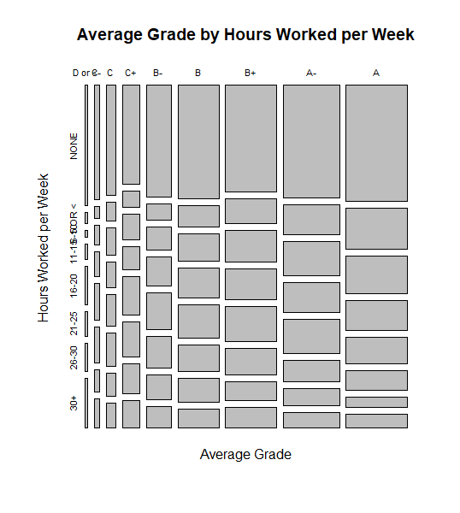

Figure: 11 Correlation between average high school grade and how hours worked per week among 12th grade students in 2019.

We found this data interesting as well because it can be seen the more hours a student works per week the lower their grades generally are. There are very few students that work 30+ hours and have as compared to those that work 30+ hours and have Cs or Bs.

**Appendix B**

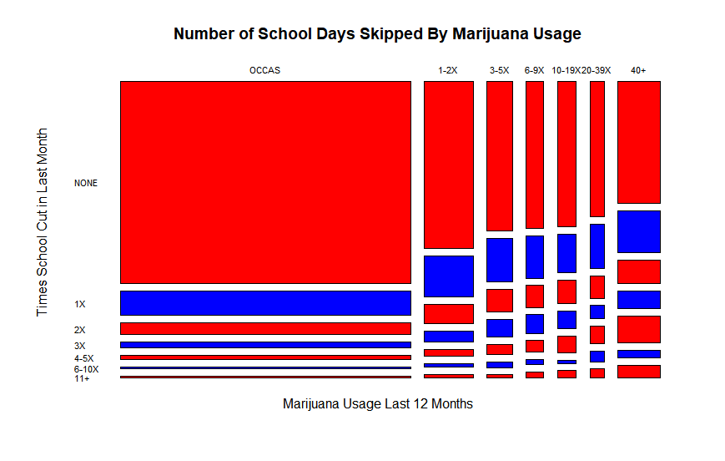

Figure 12: A chi-squared test found a chi-squared statistic of 1002.7, 36 degrees of freedom with a significant p-value of 2.2 x 10-16

A correlation between skipping school and marijuana usage was drawn to submit a possible prediction of substance altercation in college intentions. The chi-squared test between these two variables found a strong relationship between these variables. Attendance in school plays a large role in the intention for college, and the usage of both alcohol and marijuana has a strong correlation with cutting school.

While there was a significance between the two values, the result provides very little insight into college intentions in reality outside of prediction.

**References**

Milot, A. S., & Ludden, A. B. (2009). The effects of religion and gender on well-being, substance use and academic engagement among rural adolescents. *Youth & Society, 40*(3), 403–425. <https://doi.org/10.1177/0044118X08316668>

Centers for Disease Control and Prevention. (2021). Alcohol behaviors and academic grades. *Centers for Disease Control and Prevention*. Retrieved May 7, 2023, from https://www.cdc.gov/healthyschools/health_and_academics/alcohol_use.htm

El Ansari, W., Stock, C., & Mills, C. (2013). Is alcohol consumption associated with poor academic achievement in university students? *International Journal of Preventive Medicine, 4*(10)*, 1175-1188.*  PMID: 24319558; PMCID: PMC3843305.

Drug Enforcement Administration. (2021). School failure. Get Smart About Drugs. Retrieved May 7, 2023, from <https://www.getsmartaboutdrugs.gov/content/school-failure#:~:text=Dropouts%20were%20more%20likely%20to,5.1%20percent>.

Miech, Richard A., Johnston, Lloyd D., Bachman, Jerald G., O’Malley, Patrick M., Schulenberg, John E., and Patrick, Megan E. Monitoring the Future: A Continuing Study of American Youth, 2019 [Restricted-Use]. Inter-university Consortium for Political and Social Research [distributor], 2020-10-29. <https://doi.org/10.3886/ICPSR37882.v1>

McCaffrey, D. F., Pacula, R. L., Han, B., & Ellickson, P. (2010). Marijuana use and high school dropout: the influence of unobservables. *Health economics*, *19*(11), 1281–1299. <https://doi.org/10.1002/hec.1561>